Tables:
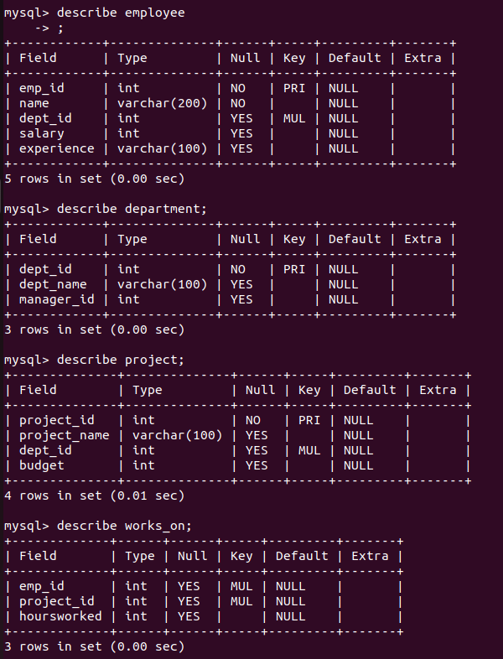
Nested Queries:
1. Find departments that have at least one employee with a salary greater than 60,000.
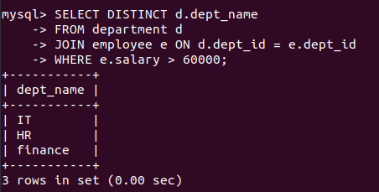

2. Find employees who work on projects in their own department.
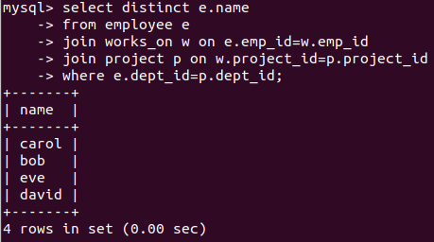

3. Find departments where all employees earn more than the average salary of the entire company.
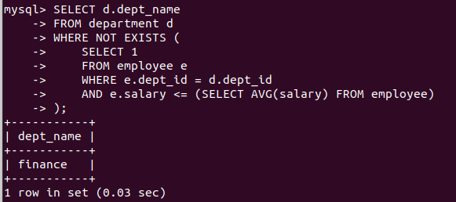
4. Find employees who work on all projects handled by the ‘HR’ department.
5. Find employees who are working on projects with a budget greater than 600,000.
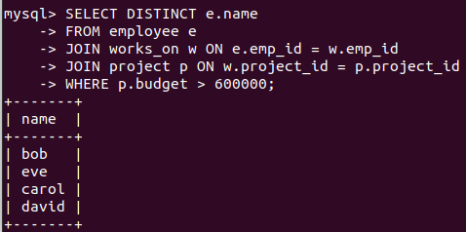
6. Find the total salary paid in each department.
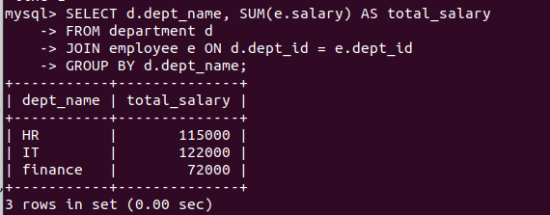
7. Find departments where the total salary of employees exceeds 100,000.

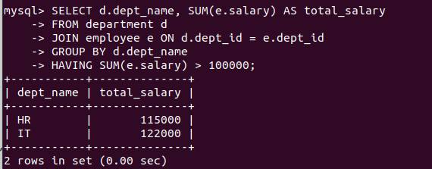
8. Find projects where the total hours worked exceeds the average hours worked across all projects.
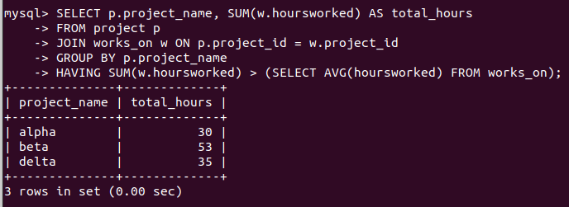
9. Find departments where the average salary of employees is greater than 60,000. (Use Join).
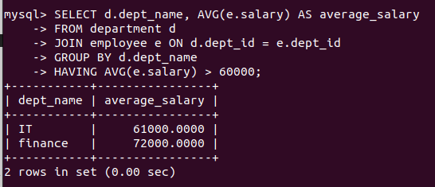

10. Find departments where the average salary is higher than the overall company’s average salary. (Use a nested subquery in the Having Clause).
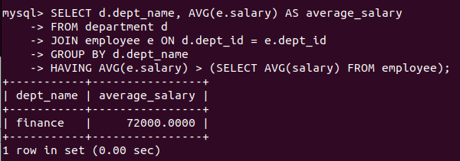
11. Observe the given output table and write an SQL query that produces this result. Additionally, describe the query in plain English.
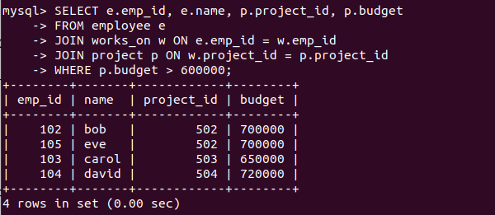
12. Observe the given output table and write an SQL query that produces this result. Additionally, describe the query in plain English.
